Getting to know Laura Vannini
Laura Vannini works in AFBI’s Grassland and Plant Sciences Branch in Belfast. Here, we find out more about Laura and her interests inside and outside of work.
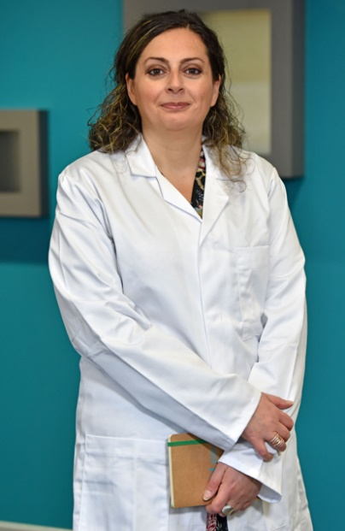
Hi Laura. Tell us a bit about yourself. I grew up in Italy and after about 15 years in academia at the University of Siena (Italy) and University of Georgia (US), I moved to Northern Ireland where I began working for AFBI 2 years ago.
What attracted you to work for AFBI? I have been a Molecular Biologist throughout my career and wanted to keep working in this field, preferably on something related to my Ph.D. AFBI provided me with the opportunity I was looking for.
Tell us about your career with AFBI. I spent my first year at AFBI in the Bacteriology unit where I was involved in statutory work. The expertise required there was a perfect fit for me. I had the chance to apply techniques that I already knew and acquire new ones. When I left the unit for a promotional opportunity, I knew I would be very lucky if my new lab was half as good as the old one. Currently I am in GPS and I just love it! I’m involved in research now and I have many opportunities to continue developing my scientific knowledge.
What are you passionate about outside of work? I love painting and do it whenever I have time. My favourite media is oil, but I like to experiment with acrylics and watercolours too. I also spend lots of time mixing and stirring things in the kitchen, for that practice known as cooking. I think I get good results in this, or at least I often pass my husband’s quality control.

