Getting to know Karina O’Neill
Karina O’Neill works in AFBI’s Grassland and Plant Sciences Branch in Belfast. Here, we find out more about Karina and her interests inside and outside of work.
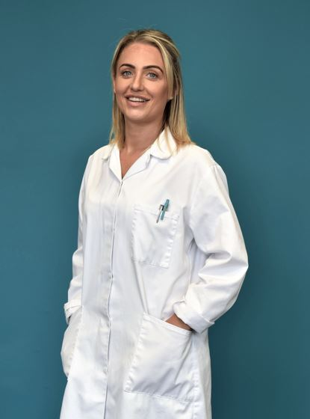
Hi Karina. Tell us a bit about yourself. My name is Karina O’Neill and I have worked at Newforge, as a SGB2, for fifteen years in Crop Pathology.
Tell us about your career with AFBI. I started working for AFBI in 2007. My main role is to carryout statutory testing of bacterial and viral pathogens that infect potatoes following EPPO standards. A typical day can be preparing buffers for the week ahead. Also, it can involve performing the relevant testing and general housekeeping of the lab.

Can you tell me an interesting fact about your job? I enjoy finding work that interests and challenges me as I am very driven, and I like to take pride in everything I do. Also, I find it more interesting having a variety of tasks to do. At the moment we have quite a number of new people in our branch and as I am a people person, I enjoy getting to know them and consequently building working relationships with them.

What are you passionate about outside of work? I enjoy spending time with my family, especially my daughter, as we both love to go to the park for walks and then maybe get a takeaway for tea, which is safer than eating a meal prepared by myself! I am also very interested in fashion always keeping myself updated on the latest trends.

