EU Exceptional Adjustment Aid

Explanatory Booklet for the Soil Sampling and Analysis Scheme

Details of this Scheme may be accessed at the following link:

Agri Food and Bioscience Institute (https://www.afbini.gov.uk/eu-eaa-soil-sampling-and-analysis-scheme)

CONTENTS Page

- Introduction 3
- Contact Information 4
- Definitions 4
- Overview of the Scheme 5
- Support Available 6
- Eligibility 7
- How to apply 7
- Selection 7
- Successful applications 7
- Unsuccessful applications 8
- Declaration and Fraud 8
- Compliance checks and monitoring 8
- Amending the Scheme 9
- Data Disclosure 9-11
- Map showing targeted sub-catchments in Upper Bann 11

- Introduction

This document is the Explanatory Booklet for the EAA Soil Sampling and Analysis Scheme (the Scheme). It provides information on the Scheme and explains how to complete your application form.

Please note that the deadline for online registration for the EAA Soil Sampling and Analysis Scheme is at Noon on Monday 19th June 2017. This time-limited EAA Scheme will only be open once for online registrations.

Research has shown that by optimising pH and applying slurry, manure and chemical fertiliser in line with crop need, farmers can maximise crop yields, increase soil fertility and increase farm profitability, with further potential to improve water quality and reduce greenhouse gas and ammonia emissions.

As part of the EU’s Exceptional Adjustment Aid (EAA) Package, livestock farmers in Northern Ireland are being offered a free, whole-farm soil sampling and analysis service. The service will provide farmers with detailed information on their soils, such as pH level and nutrient (P₂O₅ & K₂O) requirements.
The Agri-Food and Biosciences Institute (AFBI), and their appointed agents, will deliver the scheme on behalf of the Department of Agriculture, Environment and Rural Affairs (DAERA).The scheme will be delivered in two components up to a maximum of 20,000 fields, limited by the available budget:
- Component 1 will be aimed at all NI livestock farmers and will be known as the “Open Scheme”.

- Component 2 will be targeted at farmers within parts of the Upper Bann catchment and will be known as the “Catchment Scheme”. Figure 1 illustrates the location of the targeted catchments within the Upper Bann.

Successful applicants will be provided with a free soil sampling and analysis service, to include sample collection by AFBI, or their appointed agent, and sample analysis performed to a UKAS accredited standard. Individual soil analysis results, together with advice on lime and nutrient applications, will be sent to participants. Training in nutrient management planning will be offered before and after soil sampling. Farmers participating in Component 2 will also be provided with additional information and advice on the potential for nutrient loss. More detail on the scheme components and how it will operate are available in Section 4.

THE SCHEME IS NOW CLOSED FOR NEW APPLICATIONS.

- Contact Information

If you have any queries you should contact the delivery agent for the Scheme, namely the Agri-Food and Biosciences Institute (AFBI).
Telephone: Colleen Ward (Project Manager) 028 90255239; Dr John McIlroy (Farm Liaison Officer) 028 90255493; Alex Higgins (Farm Data Manager) 028 90255356.

- Definitions

For the purpose of this explanatory booklet and the claim form:

“AFBI” means Agri-Food and Biosciences Institute;
“Applicant” means the farm business owner who has signed the claim form, claiming assistance under the Scheme;
“Business ID Number” means the unique identification number allocated to the legal owner of the business by the Department;
“CAFRE” means the College of Agriculture, Food and Rural Enterprise
“DAERA” means the Department of Agriculture, Environment and Rural Affairs;
“Delivery Agent” means an organisation that has been appointed by DAERA for the purposes of delivering the Scheme;
“EAA” means Exceptional Adjustment Aid
“EU” means European Union
“K” means potassium
“N” means nitrogen
“pH” means potential of hydrogen as a measure of the acidity level
“P” means phosphorus
“UKAS” means United Kingdom Accreditation Standard

- Overview of Scheme
The scheme will offer a free, whole farm soil sampling and analysis service to livestock farmers in Northern Ireland. The Agri-Food and Biosciences Institute (AFBI), and their appointed agents, will deliver the scheme on behalf of the Department of Agriculture, Environment and Rural Affairs (DAERA). The scheme will be delivered in two components up to a maximum of 20,000 fields, limited by the available budget:
- Component 1 will be aimed at all NI livestock farmers and will be known as the “Open Scheme”.

- Component 2 will be targeted at farmers within parts of the Upper Bann catchment and will be known as the “Catchment Scheme”. The location of the targeted subcatchments is illustrated in Figure 1.

These components will operate slightly differently. All successful applicants will receive a free soil sampling and analysis service and individual soil analysis results, together with advice on lime and nutrient applications. Training will also be offered prior to sampling and following receipt of results. All analysis will be undertaken to a UKAS accredited standard by a laboratory to be appointed through open competition.

Subject to a successful tender and scheme uptake participants in the Open Scheme will be contacted by AFBI’s appointed agent who will collect the soil sample at a suitable time. In the Catchment Scheme, AFBI will be responsible for collecting the soil samples and will contact and recruit farmers in the targeted catchment areas. AFBI will subsequently use the information gathered in the catchment component to help develop and demonstrate practical strategies to manage nutrients. Individual farmer data will be protected (see Section 14 for more information). Farmers in the catchment component will also be provided with farm maps and information and advice on nutrient loss. In order to maximise the effectiveness of the catchment scheme, AFBI may continue to recruit farmers within the target catchment areas beyond the registration date depending on initial uptake levels, subject to the agreed maximum limits of the scheme (see Section 5).

Soil sampling will take place from November 2017 to February 2018 (primarily during the closed period for application of organic manures) in line with best practice. AFBI, or their appointed agents, will contact participants to arrange a suitable time to collect the samples from your land. A minimum of 25 soil cores will be taken from each field to a depth of 7.5cm using a 2cm diameter soil corer, and following a GPS-referenced W-shaped sampling tour. The sampling tour will avoid dung and urine patches, gateways, headlands and areas where livestock congregate and excessive non-representative levels of manure may have been deposited.
Samples will then be sent to an accredited UKAS laboratory where they will be tested for soil pH, Olsen-P, ammonium nitrate or ammonium acetate extractable K (potassium), Magnesium (Mg) and Calcium (Ca), and Loss-on-Ignition (LOI), which can be used to provide an estimate of soil organic matter content.
Results will be sent directly to participants in the scheme, along with advice and recommendations on lime and nutrient (N, P₂O₅ & K₂O) requirements. In the Catchment Scheme, AFBI will use soil P results together with soil hydrology information and high resolution digital elevation (LiDAR) data to provide farmers with maps showing areas most at risk of P loss occurring to water in overland flow.
- Support available

The Scheme will:

- Provide a free whole-farm soil sampling and analysis service, to include sample collection by AFBI, or their appointed agents, and analysis performed by an accredited laboratory;

- Provide individual soil analysis results, together with advice on lime and nutrient applications, sent directly to participating farmers;

- Offer training and advice in nutrient planning; before and after the soil sampling

- Farmers participating in Component 2 will also be provided with maps indicating field areas most at risk of P loss occurring to water in overland flow and advice on how this risk could be reduced.

Support to farmers is to be provided as a free of charge soil sampling and analysis service. There is no direct payment to farmers participating in the scheme. The service will provide participating farmers with detailed information on their soils in order to apply nutrients in line with crop requirements.

A maximum of 20,000 individual soil samples, limited by the available budget, will be taken by AFBI or their appointed contractor across both components of the scheme.
It is anticipated that the two components will initially be allocated a maximum of 10,000 fields each, subject to the level of interest across the scheme. Service provision may be re-distributed across the scheme depending on uptake levels.

- Eligibility

In order to be eligible for entry into the Scheme, the applicant must:

- Be registered with DAERA and have a valid Business ID number
- Be a livestock farmer registered in Northern Ireland
- Provide all mandatory information requested on the registration form

- How to apply

The on-line registration form is available using the following link:

ONLINE REGISTRATION IS NOW CLOSED.

Online registration will close at Noon on Monday 19th June 2017. Any applications received after this date may be considered ineligible for the scheme.

Please note that the completion of the soil sampling and analysis application form does not mean that DAERA is under any obligation to make an offer through the Scheme.

AFBI may also continue to recruit farmers within the target sub catchment areas beyond this date depending on initial uptake levels. AFBI or their appointed agents may contact individuals in the target areas directly to encourage participation in the catchment scheme.

- Selection criteria

If the scheme is over-subscribed AFBI will prioritise applications in specific sub catchments in Upper Bann, followed by a random selection. Details of the specific sub catchments are available from AFBI.

- Successful applications

Successful applicants will receive a confirmation letter detailing the delivery process for the soil sampling and analysis scheme. Applicants should keep a copy of the confirmation letter for their own records.

Farms may be subject to site visits for monitoring and evaluation both during and after the scheme. This work may be carried out by either AFBI or a third party.

- Unsuccessful applications

If an applicant fails to provide required information or does not agree to the conditions of the scheme, the application for the scheme will be unsuccessful. An application for the scheme will also be unsuccessful if the application submitted does not meet the eligibility criteria of the scheme. You may also be unsuccessful if the scheme is over-subscribed and selection criteria are applied.

If your application is not approved, AFBI will provide you with a written explanation of the reasons why the application was unsuccessful. If you have reason to believe that the facts have been misinterpreted or an error has occurred in processing your application, you may seek a review.

A request for a review should be submitted by the applicant, in writing, to AFBI within 14 working days of the date on your letter advising that your application has not been approved. You should set out the reasons why you feel that an error was made in determining the eligibility of your application. The applicant will be informed of the outcome of the review in writing.

- Declaration and Fraud
By signing and submitting the application, an applicant is declaring that to the best of their knowledge all information provided is true and complete. You are confirming that you have read and understood the scheme guidance as set out in this Explanatory Booklet and are agreeing to participate in the Soil Sampling and Analysis Scheme.

False declarations may lead to disqualification from the scheme.

AFBI and DAERA will take steps to indentify and pursue any suspected incidence of fraud.
- Compliance and monitoring checks
To enable the delivery agent and/or DAERA to verify the accuracy of information submitted by applicants, all applications will be subject to systematic administrative checks and controls, which may include:
- Review and cross-checking of information held by DAERA
- On-farm verification visits to verify the delivery of the service.

- Amending the Scheme

AFBI, on behalf of DAREA, reserve the right to amend or alter eligibility criteria and Scheme rules, and to close the Scheme at any time.

AFBI, DAERA, or their appointed agents, shall not bear any liability to scheme successful applicants where, as a result of force majeure, it is not possible to provide the free soil sampling and analysis service by 28 February 2018.

Force majeure is defined as any circumstance not within the reasonable control of AFBI and/or DAERA including, but without limitation, acts of God, severe and adverse weather conditions, natural disasters, epidemic or pandemic, an agricultural or environmental emergency as determined by DAERA or other competent UK statutory authority which requires an emergency response by AFBI, terrorist attack, civil commotion, armed conflict, imposition of sanctions, embargo, nuclear, chemical or biological contamination, any law or any action taken by a government or public authority, collapse of buildings, fire, explosion or accident, any labour or trade dispute, strike, industrial action or lockout or interruption or failure of utility service.

- Data disclosure

Information provided in your application will be shared by AFBI with DAERA and subcontracted partners. All information will be processed in line with the requirements of the Data Protection Act 1998. AFBI may also use the information provided for other legitimate purposes in line with the Data Protection Act 1998, the Freedom of Information Act 2000 and the Environmental Information Regulations 2004 legislation, the compilation of statistics and disclosure to other organisations when required to do so.
We may need to share data with other bodies responsible for auditing and administering public funds, in order to stop fraud and to protect the European funds that support the Common Agricultural Policy. If so, we will still follow the rules set by the Data Protection Act and Directive 95/46/EC and Regulation (EC) No 45/2001.
As the service you receive under the Soil Sampling and Analysis Scheme forms part of the Common Agricultural Policy, your details and the details of the amounts of payments you receive may be published on the website of the UK Co-ordinating Body for two years (see http://cap-payments.defra.gov.uk/Default.aspx).
You may be contacted in the future and asked to give feedback about your experience of using the Scheme. This information will be used to report to the European Commission on the effectiveness of the Scheme and to improve the design of any future DAERA schemes.
Information relating to the scheme may also be used for the compilation of statistics and evaluation, and may be disclosed to other organisations for this purpose, but will not identify any individual and will be shared in accordance with the Data Protection Act.

- What personal data AFBI needs to collect from you
See Section 1 ‘Applicant Details’ on the registration form for the information AFBI needs from you. This is the minimum amount of your personal information that AFBI requires to carry out the scheme.
- Why AFBI needs to collect this personal data
Your personal data are required to clearly distinguish your farm holdings on the farm information system, in order to facilitate the entire administration of soil sampling and analysis scheme
- How AFBI will use your personal data
We will only use your data to identify the fields on your farm holdings for the entire administration of soil sampling and analysis scheme within the EU Exceptional Aid Adjustment.
- Who AFBI will share your personal data with
- Soil Sampling sub contractors – AFBI will give the contractor your name, address telephone number(s) and farm map(s) so their staff can visit your property to carry out the soil sampling
- Soil Analysis sub contractors – AFBI will give the contractor your name and address so their staff can post the results of your soil tests to you.
- Department of Agriculture, Environment and Rural Affairs (DAERA) and auditors of the scheme– AFBI has agreed to provide personal data to DAERA and any auditors connected with the scheme for the purposes of administering, monitoring and evaluating the scheme, processing and verifying payments and to meet audit requirements to check that the scheme is being managed and run correctly. They will abide by the Data Protection Act and any other relevant legislation while they perform this work.
- How long AFBI will keep your personal data
Following the end of the project, AFBI will only keep your personal data for as long as required by relevant legislation and will then delete your personal data from its systems and dispose of any paper records.
- How AFBI will protect your personal data
We will make sure that only staff who are fully trained and need to see your personal data as part of the project will do so. Your data will be held securely within a computerised and/or manual filing system.
If we transfer any data to DAERA or sub-contractors, we shall make sure that your personal data are kept separate from test results so that your field results cannot be attributed directly to you. To ensure the privacy and security of your personal data, any electronic information that is to be transferred will be password-protected and/or encrypted.

- Map showing targeted sub-catchments in Upper Bann

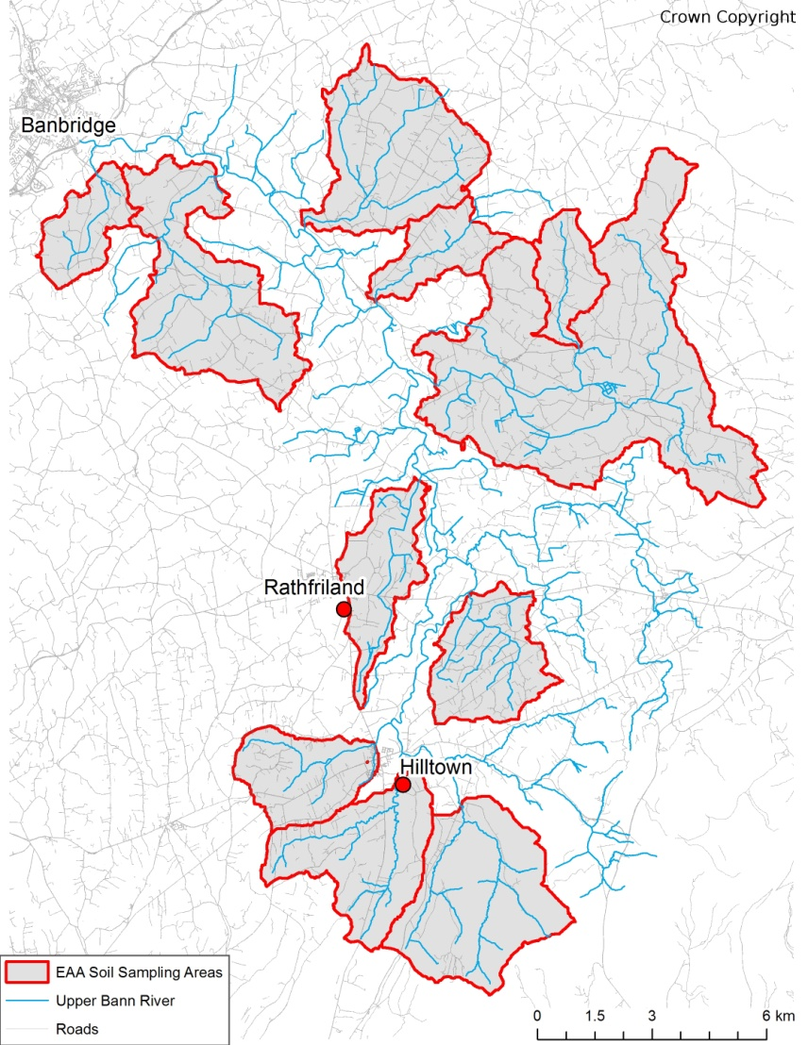
Figure 1. Targeted subcatchments within Component 2 of the EU EAA Soil Sampling and Analysis Scheme.

Livestock farmers are defined in Commission Delegated Regulation (EU) 2016/1613 as the beef and veal, milk and milk products, pigmeat and sheepmeat and goatmeat sectors
Livestock farmers are defined in Commission Delegated Regulation (EU) 2016/1613 as the beef and veal, milk and milk products, pigmeat and sheepmeat and goatmeat sectors

